**Life Management**

**Maintenance Manual**

We recommend to use git source control in the following manner.

In the Team explorer, make sure you are in the home screen by clicking the home icon. then click branches.

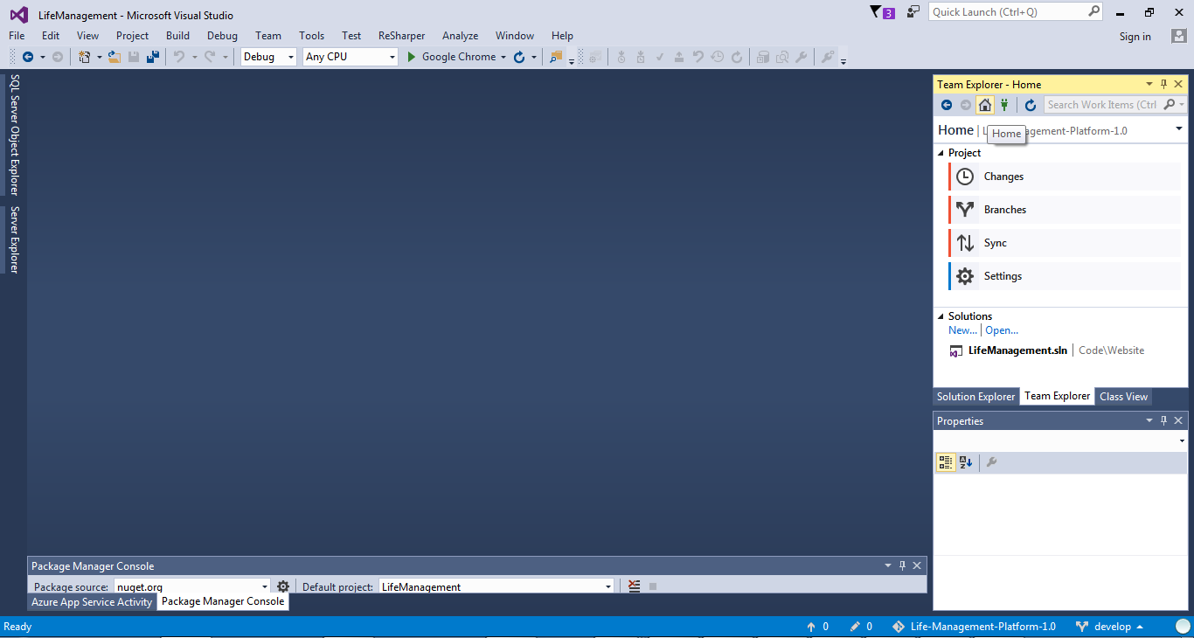

Right click Life-Management-Platform-1.0 and then "Open command prompt". This tutorial assumes you have git installed.

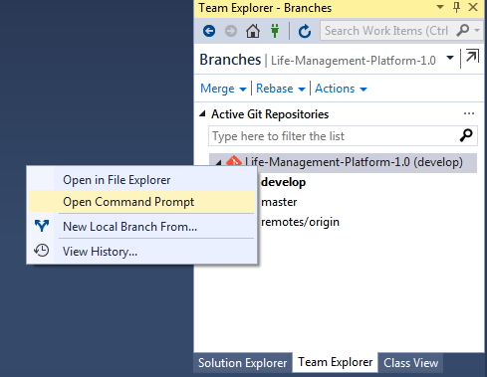

If you need to add code or any other modification

1- Create a new branch from develop using the command **"git checkout -b <nameofyourbranch> develop"** and press enter

2- Go to visual studio and work on your modifications. when done, go back the command prompt and execute **"git add -A"** to add or delete files

3- Then **"git commit -m "explanatory message about changes"**

4- Change to develop using **"checkout develop"**

5- Merge it with the new branch using the command **"git merge --no-ff <nameofyourbranch>"**

6- Pull the source control server files using "**git pull"** from develop and resolve any conflicts that may appear.

7- Then push the new version of your develop to the server using **"git push"**

8- Delete the branch using **"git branch -d <nameofyourbranch>"**

After this, publish your changes using the steps previously explained.